**Experiment**

**Hardware and software**

The environment of experiment is a two floor residential house. Images for the experiment are collected using iPhone Max Xs. The specification of the phone camera can be read from its Exif meta-data. To be specific, the sensor size of the camera is 5.6 mm * 4.2 mm; the focal length is 4.25 mm. The sensor size and the focal length will be used to calculate the FOV of the camera. Considering the use of camera in the actual indoor positioning scenarios, the iPhone is vertically positioned while taking images.

Software used for the experiment are Visual Studio Code and Python. Visual Studio Code is a free and mature software development environment. Python is a mainstream programming language. In this project, Python version 2.7 is used. Some libraries are deployed to provide basic operational and mathematical functions, such as reading/writing files, and trigonometric calculations.

The operation systems for the experiment is macOS Catalina with processor 3.1 GHz 6-Core Intel i5 and graphics Radeon Pro 575X 4 GB.

**Design and result of three experiments**

Three experiments are designed according to the discussions in the previous section.

The first experiment evaluates the the accuracy of image matching using the SIFT algorithm. The second experiment evaluates the method for position correction. The third experiment justifies the use of confidence measurement for image matching.

**Experiment 1 : accuracy of image matching using SIFT algorithm**

Design: Experiment 1 involves three steps: 1) images are collected in the experimental environment - residential house, as reference images, 2) An image database is created from the collected reference images, 3) an image matching program is written to find the best-matched image from the image database, 4) query images are randomly taken, and fed into the image matching program to find their matched reference images for position estimation.

Step 1: Given that the experiment is carried out in a residential house whose space is limited, 59 reference images are collected and assumed to be enough to meet the experiment needs - covering all the noticeable features in the house. The naming of the images are based on the main feature in the image e.g. hallway.

Step 2: From the reference images is created an image database. The image database stores key-points and descriptors of reference images. The key points and descriptors are essential for the image matching. The key point and descriptor information are generated using the SIFT algorithm described in the previous section.

It is worth noting that preparing the image database is a time-consuming tasks given that all the reference images have to be processed at pixel-level. The time required to prepare the image database can vary based on the computing capacity, volume of images and their resolution. In this experiment, preparing the image database takes approximate 2 minutes.

Step 3: After the image database is created, an image matching program is written to read a query image and make find their best-matched reference image from the image database. The image matching of the query images involves two steps. Firstly, descriptors of the query image are matched with descriptors of each reference image in the image database. Two commonly used algorithms for matching descriptors are BF (brute-force) and FLANN (Fast Library for Approximate Nearest Neighbors). A simple testing is made to compare their performance. Figure X shows the testing result of matching two hallway pictures using both BF and FLANN. Both algorithms find 53656 matched pairs between the two images. However, BF takes 30.54s while FLANN only takes 5.02s.

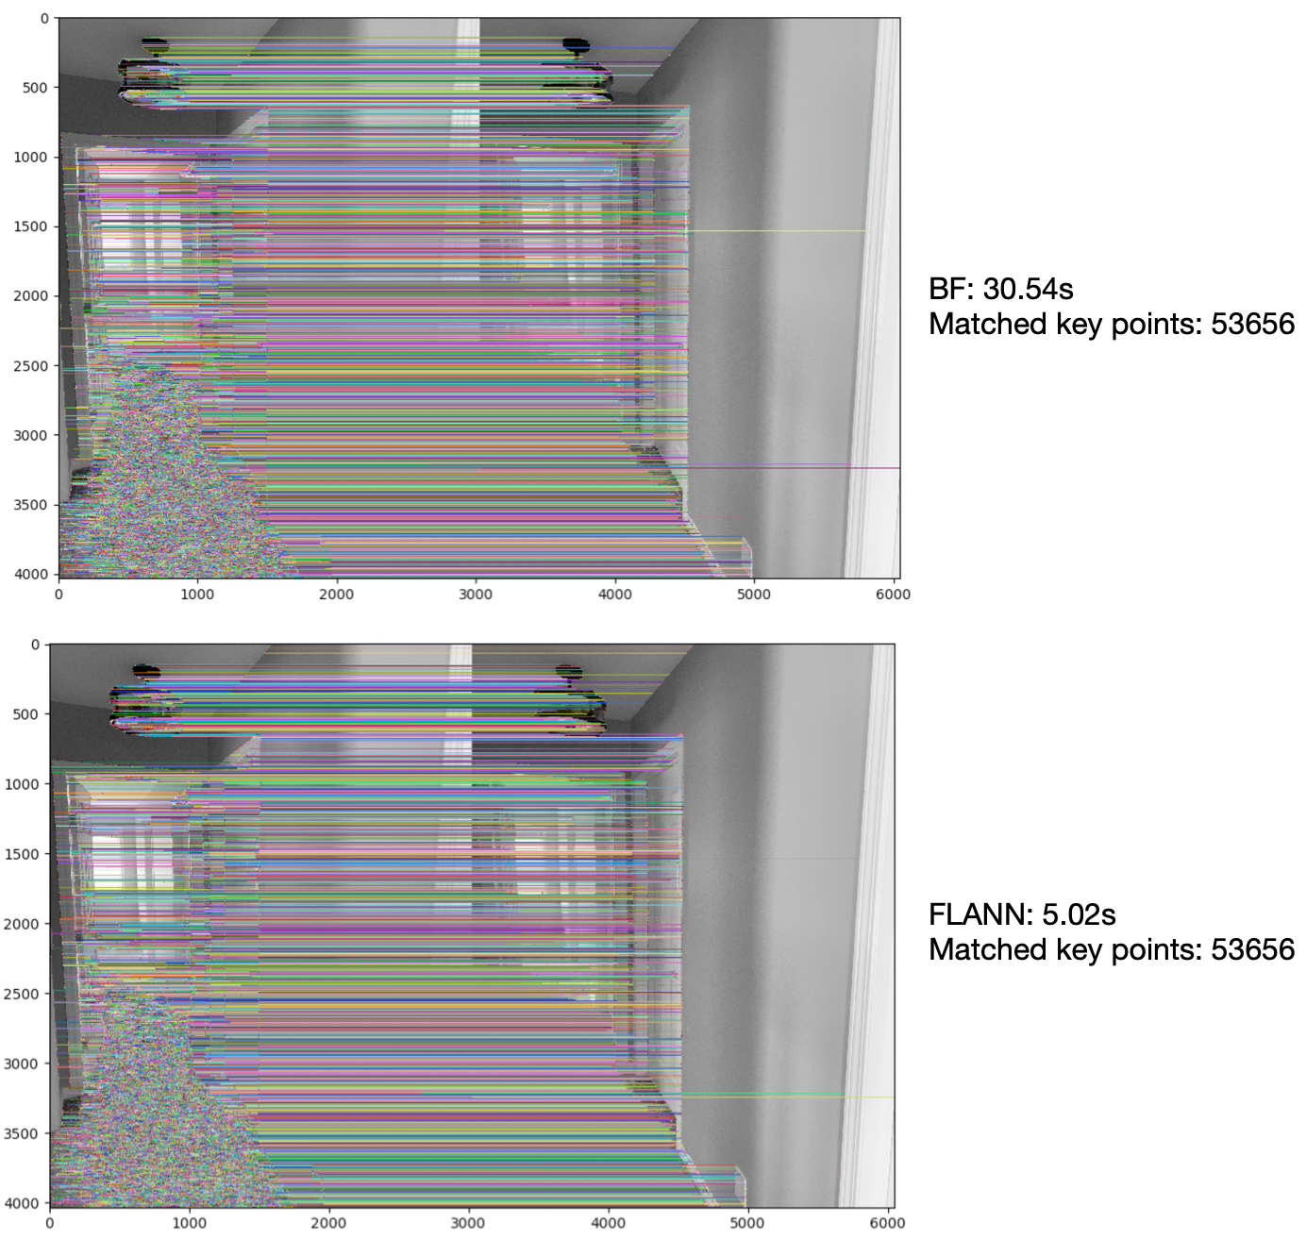

Figure 1: Comparison of BF and FLANN for image matching

Secondly, based on the number of matched key-points in the reference images, the best-matched image is determined. Figure X illustrates how the best-matched reference image is determined by the number of matched key-points. In the Figure, the query image is compared with two reference images from the image database. The matching result shows that 1073 good matched key points are found in the first reference image and 99 found in the second. Hence the first reference image is a better match than the second reference image. With the position where the first image is taken available, the position where the query image is taken can be estimated.

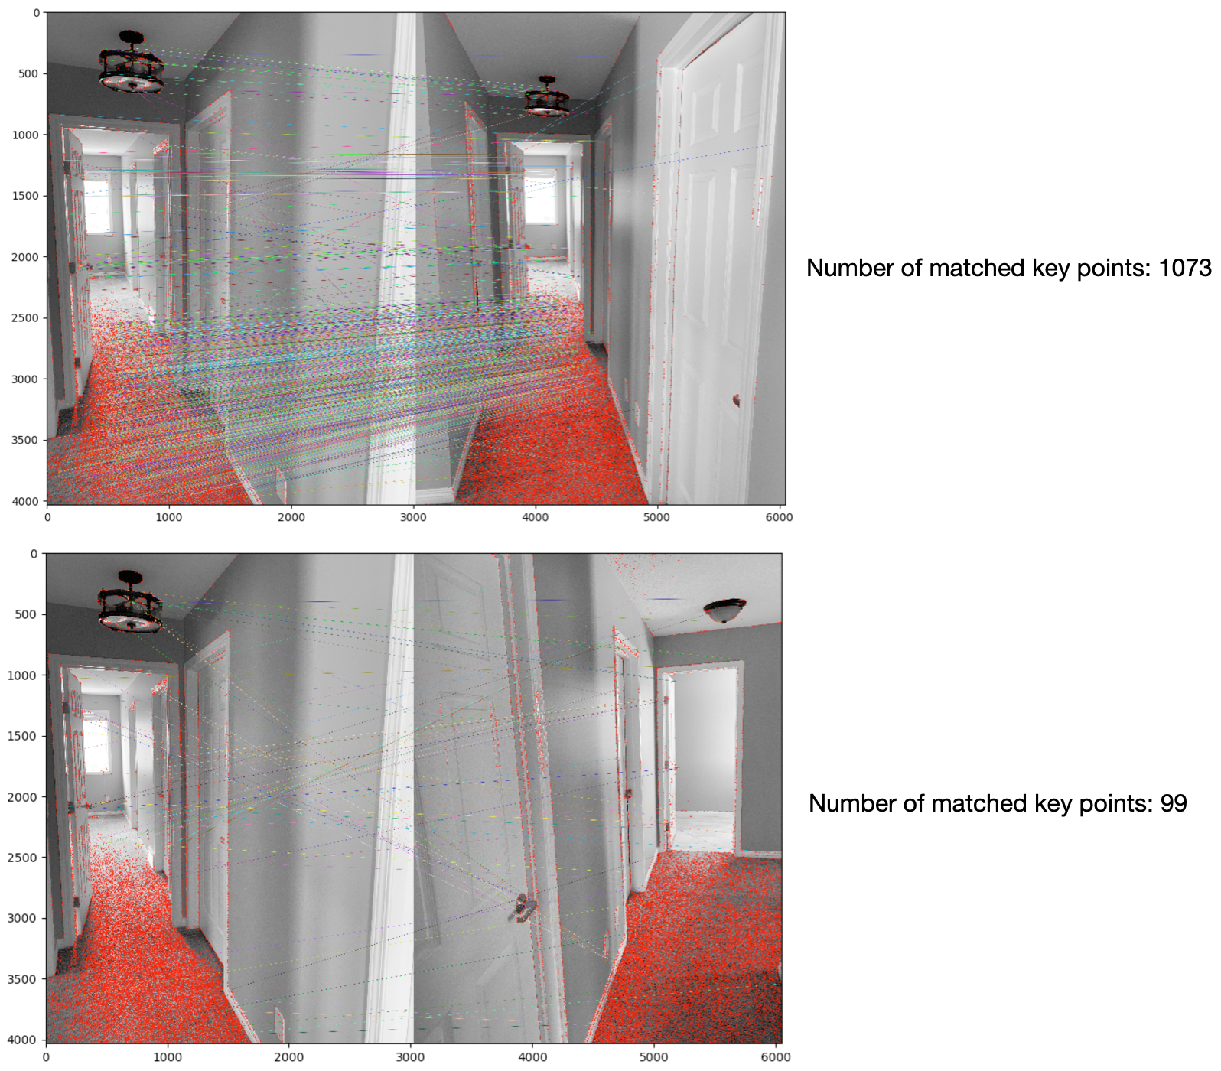

Figure 2: Selecting the better-matched image by the number of matched key points

Step 4: 8 query images are taken and fed into the image matching program respectively to find their best-matched reference images. The best-matched reference images have been marked for each query image before the running the program. The aim is to check 1) if the best-matched images can be matched with the query images, and 2) if the position where the best-matched reference image was taken can be used to estimate the position where the query image was taken.

Result: Figure 3 shows the result of image matching of the 8 query images. Except for the query image 6, other query images are successfully matched with the correct reference images. The reason of failed matching will be discussed in the later Discussion section.

On observing the matching result, when the query images are matched with correct reference images, its camera position can be reasonably assumed as that of the matched reference image. In this case, the deviation is no more than 2 meters.

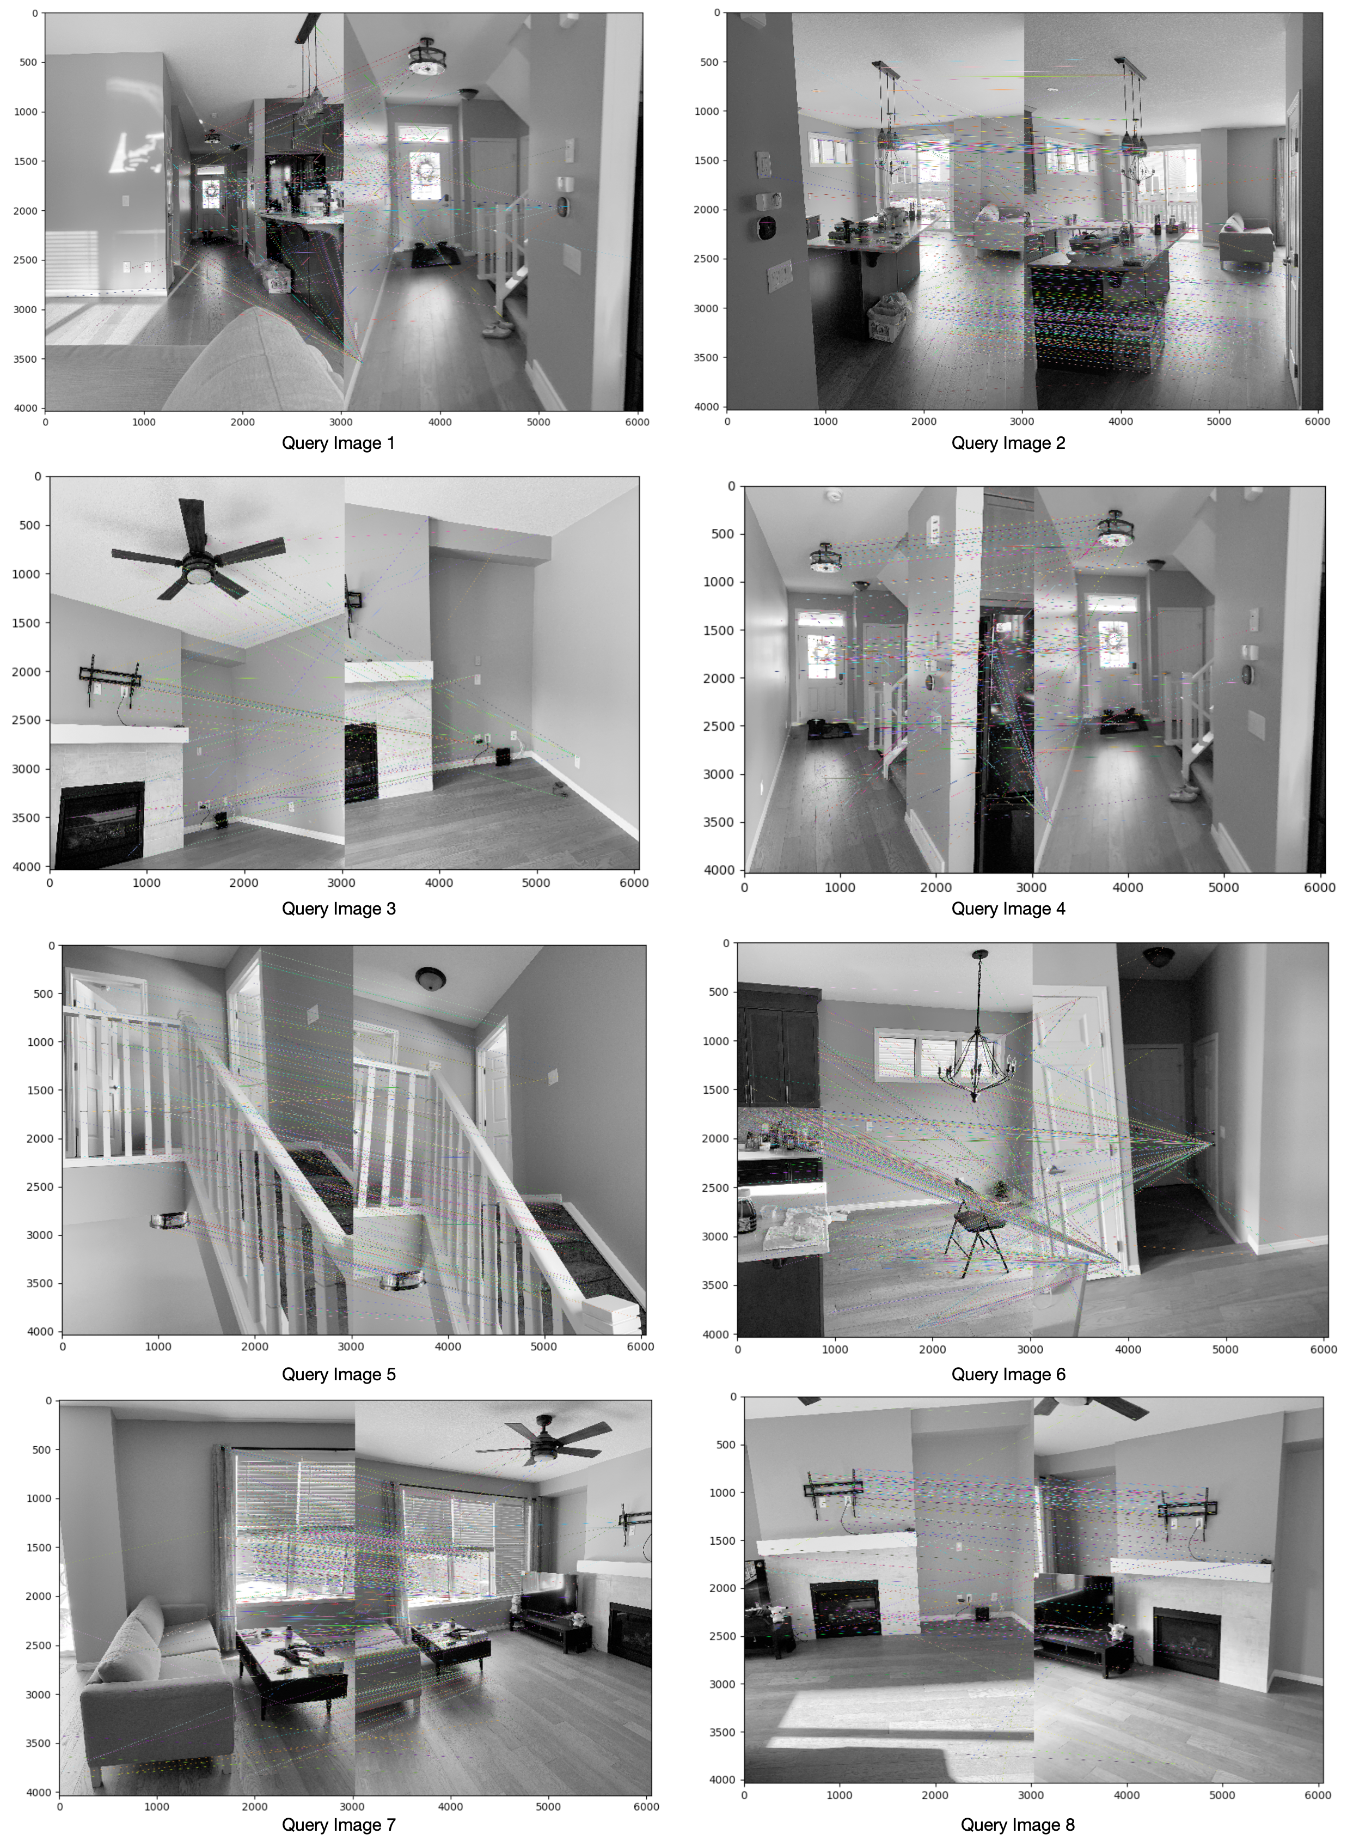

Figure 3: Best-matched reference image for each query image

**Experiment 2: positioning improvement with consideration of camera distance**

Design: Experiment 1 shows the adequate results of image matching and implies the appropriateness of using image matching for estimating indoor positions. But it is worth noting that estimating positions solely based on feature matching can be error-prone, if the camera distance is not considered. Experiment 2 aims to improve the estimation of indoor positioning by taking into the consideration of camera distance. The rationale is that the difference of the camera distances of the reference image and query image can be useful information to improve the accuracy of indoor positioning. This experiment involves two steps: 1) two images are taken for a same object and with different camera distances, and 2) the position correction schema is applied to calculate the difference of the camera distances of the reference image and query image.

Step1: Figure 4 shows two images captured with different camera distances. The left image is captured at a distance of ~0.3m and the right image is captured at a distance of ~0.6m. In this experiment, it is assumed that the left image is the reference image and the right image is the query image. The image matching between the two image is executed as indicated by the Figure.

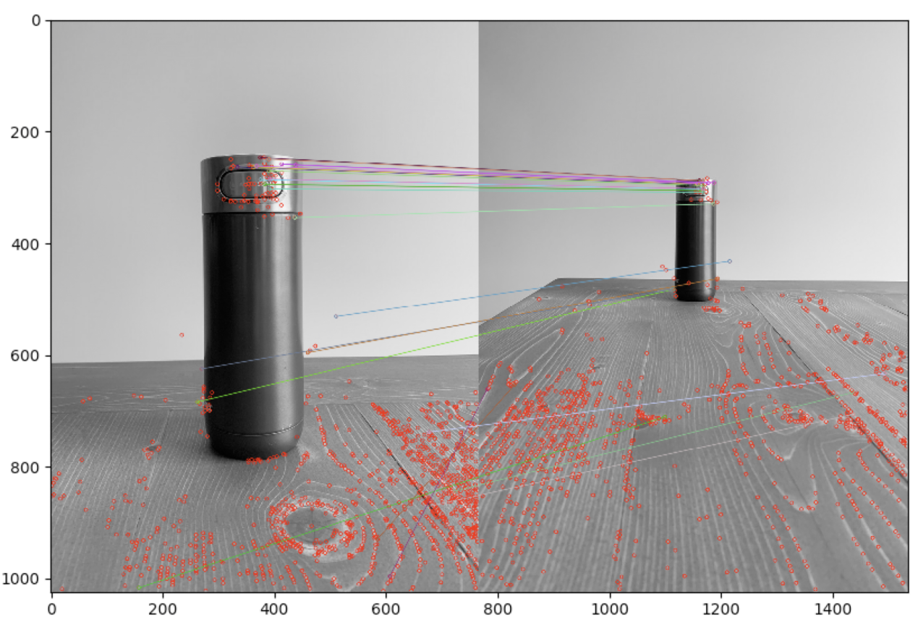

Experiment 4: calculate matching confidence

Step 2: A program is written to implement the position correction scheme. The aim is to calculate the ratio of two camera distances. The ratio of the two camera distances is proportional to the ratio of the bottle size in the two images, which can be estimated by the calculation of the respective ratio for each pair of matching points. For convenience, the equation of distance to object is put here.



After the calculation, the ratio of the camera distances is obtained to be 1.98, which is close the the real distance ratio of the camera distances ~0.6m/~0.3m.

Design:

Preparation:

The matching confidence denotes how confident the image matching is. It is based on the assumption that users tend to place the object of interest at the centre of camera and calculated as the average distance from matched points to the image centre. This measure is important for selecting the best-matched image.

Performance

Discussion

The experiment

adequate images need to be collected

1. Illumination

3. avoid capturing objects with noise information -- floors

Accuracy of position estimation

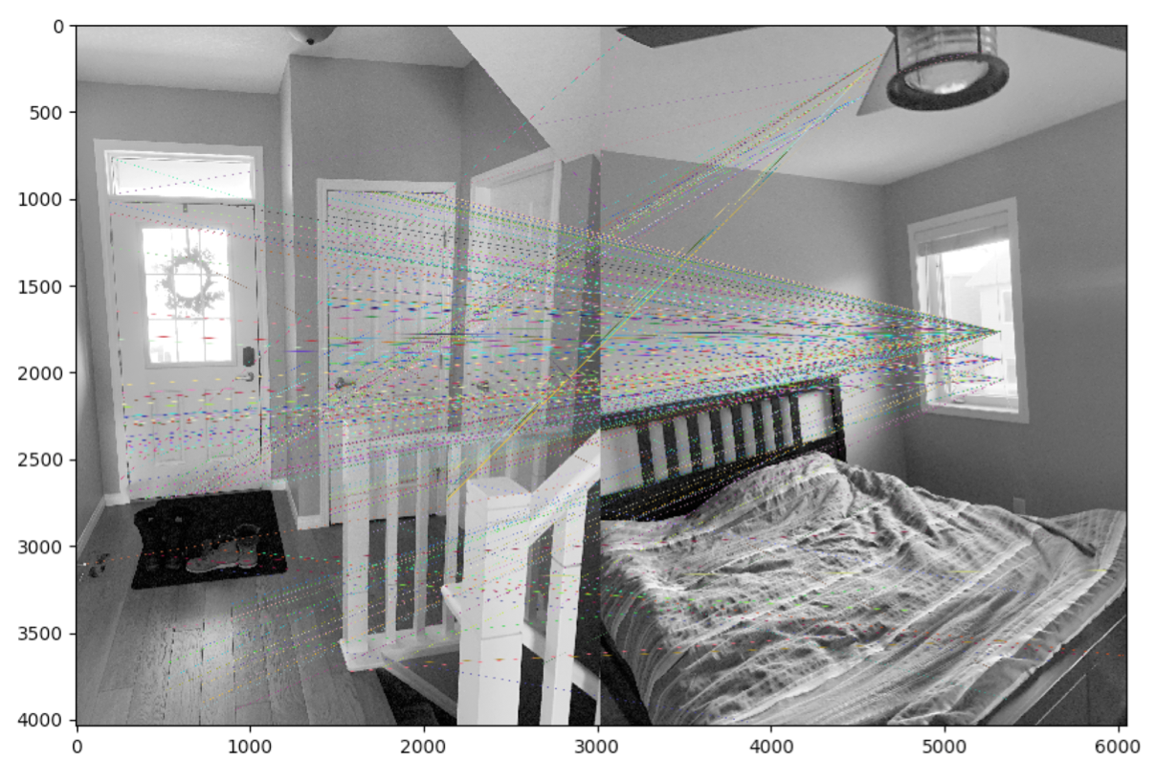

Conclusion